**Apollinaire, Guillaume**

**Tara S. Thomson, University of Edinburgh**

**Introductory Thumbnail (200 words):**

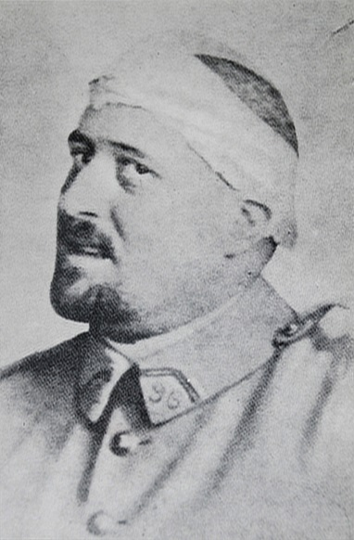Guillaume Apollinaire (1880-1918) was a poet, literary and art critic, playwright, novelist, editor, and journalist. Born in Rome to a Polish-Russian mother and an unknown father, Apollinaire’s birth name was Guglielmo Alberto Wladimiro Alessandro Apollinare de Kostrowitzky, though his family called him Wilhelm (the German form of the Italian Guglielmo). After spending his early years moving throughout Monaco, France, Belgium, and Germany, he finally settled in Paris in 1902, adopting the pen name Guillaume Apollinaire. Apollinaire became a prominent cultural figure in Paris and was a key player in the literary and artistic avant-garde movements of the early twentieth century, particularly Cubism and Surrealism.

Apollinaire first gained literary recognition for his poetry collection *Alcools* (1913), but is best known for inventing calligrams, a form of visual poetry. While Apollinaire was primarily a poet, he earned his living as a journalist and art critic. In his articles and reviews, he championed avant-garde art, and was friends with such artists as Pablo Picasso and Henri Matisse.

Apollinaire fought for France in WWI and returned home in 1916 after receiving a head wound. He survived the war, but died of Spanish Flu in 1918. (For more biographical details, see Campa)

Guillaume Apollinaire, 1916, after being treated for a head wound in WWI.

https://commons.wikimedia.org/wiki/File:Guillaume_Apollinaire_foto.jpg

**Apollinaire the poet:**

Apollinaire wrote poetry as a child, and published his first poems in 1901 in *La Grande France*. While he published earlier poems and collections, *Alcools* (1913) is considered his first major work, a collection of experimental poetry, influenced by movements including French Symbolism and Futurism. The volume opens with its most famous free verse poem, ‘Zone,’ in which Apollinaire sets out his vision of modernity (see 2013 translation and introduction by David Lehman).

Apollinaire’s poetry was experimental in a number of interesting ways. His work eschews traditional meter and rhyme, entirely eliminates punctuation, and experiments with typography and layout. He also used innovative composition techniques, such as automatic writing (anticipating surrealist poetry), and recording snippets of overheard conversations.

Like Ezra Pound, Apollinaire had an interest in Chinese ideograms, although his poetic project differs formally from Pound’s. Critic Willard Bohn has observed that ‘his works are sprinkled with references to ideographic expression, beginning with his earliest poetry’ (*Modern Visual Poetry* 38). This interest led him to develop calligrams, a form of visual poetry in which the layout of the poem mimics the content. For instance, the three elements of the poem ‘Coeur, Couronne et Miroir’ [‘Heart, Crown and Mirror’] are shaped as a heart, a crown, and a mirror:

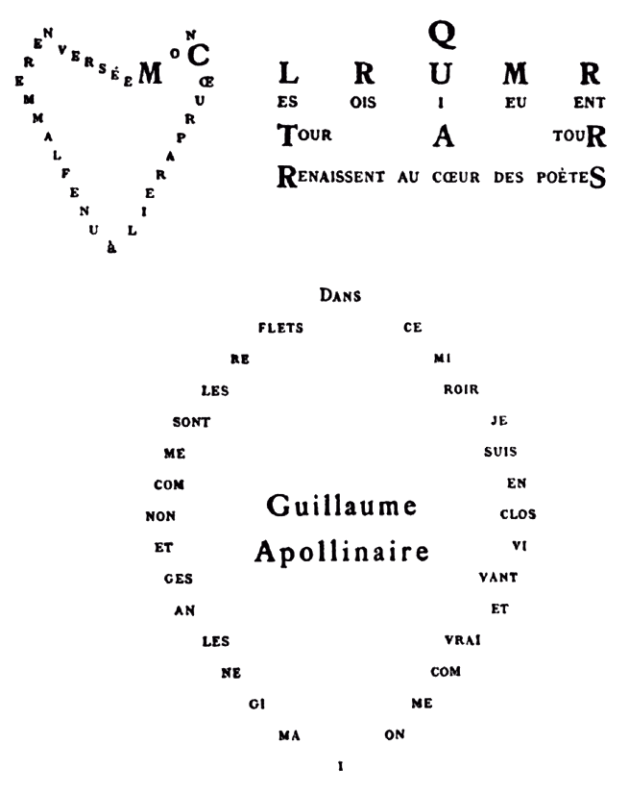

‘Coeur, Couronne et Miroir,’ by Guillaume Apollinaire, from *Calligrammes: Poèmes de la Paix et du Guerre* (1918). See Anne Hyde Greet’s English translation of *Calligrammes*, p. 89

<https://commons.wikimedia.org/wiki/File%3AGuillaume_Apollinaire_-_Calligramme_-_C%C5%93ur%2C_couronne_et_miroir.png>

Typographical layout is essential to a calligram’s meaning – it is meant to be simultaneously seen and heard, a poem that unfolds spatially rather than temporally. The name calligram is a portmanteau, combining the words ‘calligraphy’ and ‘ideogram’, but also derives from the Greek *kalos* and *gramma* for ‘beautiful letters’: ‘It is thus a pedantic word for *belles-lettres* … a cliché which it renews by calling attention to the materiality of literary letters’ (Nesselroth qtd. in Bohn *Modern Visual Poetry* 38).

Apollinaire wrote around 100 calligrams between 1914 and 1917, and some of the most famous ones appear in the collection *Calligrammes: poèmes de la paix et de la guerre 1913-1916*, published shortly after his death in 1918. Not all of the poems in *Calligrammes* are calligrams; the majority of the collection is composed of traditionally typeset poems, although they are still experimental in other ways, many reflecting on his experiences during the war, his ideas about modern aesthetics, and the impact of modern technology in early twentieth-century Europe. Some of the calligrams in the collection, and a great many after, are handwritten images, as Apollinaire became frustrated with the limits of typography, and with typographers who compromised his compositions. The handwritten poems emphasise calligraphy as an artistic element essential to the form. Many of Apollinaire’s most famous handwritten calligrams were originally published in a catalogue for a 1917 art exhibition, including ‘Le Cheval,’ which is unique among the calligrams because the text is not about a horse, but instead invites readers to embrace the new art form featured at the exhibition (see Bohn *Apollinaire, Visual Poetry, and Art Criticism*). It is also notable for being signed by the poet, unlike the other calligrams.

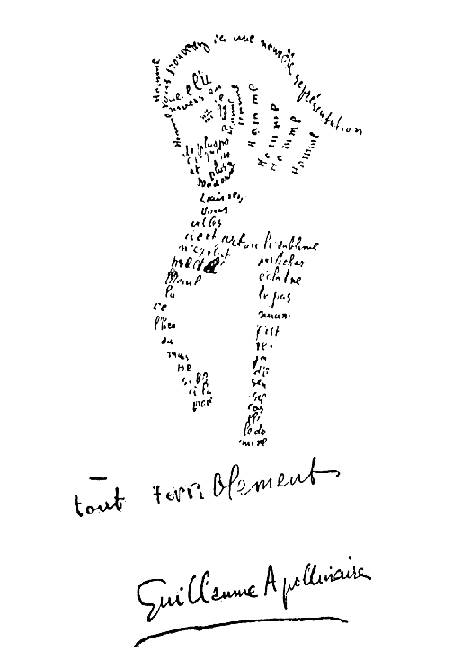

‘Le Cheval’, by Guillaume Apollinaire [Public domain], via Wikimedia Commons. For a French transcription and English translation of the poem, see Bohn *Apollinaire, Visual Poetry, and Art Criticism*, page 118.

https://commons.wikimedia.org/wiki/File:Guillaume_Apollinaire_-_Calligramme_-_Cheval.png

Apollinaire also wrote several works of prose, most of which have not been widely translated, including two novels, *Le Poète Assassiné* (translated into English as *The Poet Assassinated* in 1923 but not reprinted in English since) and *La Femme Assise*. *L’Hérésiarque et Cie* was a collection of short stories in which he explored religious themes. He also wrote three erotic novels, one of which has since been lost, and three plays, including *Les Memelles de Tiresias* (written in 1903 and first performed in 1917), in which he coined the term ‘surrealism.’ The term was later adopted by his friend André Breton to name the literary and artistic movement he launched with *The First Manifesto of Surrealism* (1924), which was dedicated to Apollinaire’s memory.

**Apollinaire the Critic:**

While Apollinaire is now recognized primarily as a poet, he made his living as a journalist and art critic. His career as a critic began in May 1902 with his first published article in the *Revue Blanche*. He continued to publish reviews and articles about art and the European art world, and wrote regular columns and reviews for publications such as the *Mercure de France*, *L’Intransigeant*, and *Paris-Journal*. Within just a few short years, he became well known and regarded amongst the Paris avant-garde, and befriended many painters and writers, including Pablo Picasso, Henri Matisse, Robert Delaunay, Marcel Duchamp, Alfred Jarry, Blaise Cendrars, and many others. Over the coming years, his criticism and his active involvement in art exhibitions helped establish the careers of several avant-garde artists, although he championed Picasso (whom he met in 1905) above all others.

In 1907, Apollinaire introduced Picasso to George Braques, working alongside them to develop Cubism. He defended their artistic innovations in several articles, claiming ‘Cubism is today the most elevated form of French art’ (Read and Apollinaire 90). In 1913, his writing on Cubism culminated in a book *Les Peintre Cubistes: Méditations Esthétiques* (*The Cubist Painters*), focused on Picasso and Braques, Jean Metzinger, Juan Gris, Fernand Léger, Francis Picabia, Marcel Duchamp, and others. In a lecture at an early Cubist exhibition, he coined the term ‘Orphism’ to define the more abstract work emerging from the movement.

His influence was felt in other avant-garde movements as well, including Dada and Surrealism. He championed surrealist artists such as Marc Chagall and Giorgio de Chirico. Apollinaire also wrote articles about Futurism while it was in its early days, and even contributed to the collection of futurist manifestoes with *L’Antitradition Futuriste* (1913). Apollinaire’s centrality to the early twentieth-century avant-garde is evident in the many portraits of him produced by artists including Pablo Picasso, Jean Metzinger, Giorgio de Chirico, Henri Rousseau, and others.

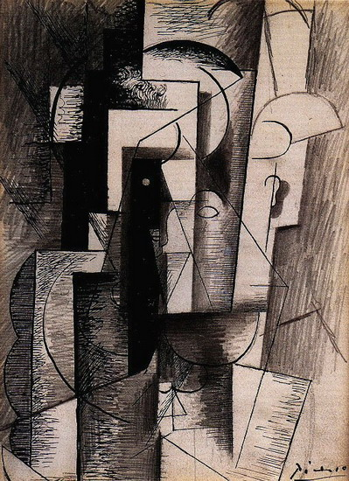

Pablo Picasso, ‘Portrait of Guillaume Apollinaire’ (1913).

<http://www.pablo-ruiz-picasso.net/images/works/2915.jpg>

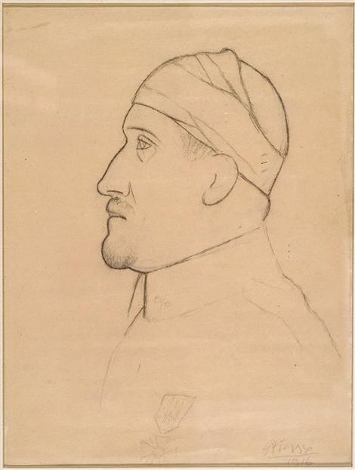

Pablo Picasso, ‘Portrait of Guillaume Apollinaire in profile with bandaged head’ (1916). Held at the Musée Picasso Paris.

http://www.museepicassoparis.fr/wp-content/uploads/2013/12/MP_1993-5_apollinaire.jpg

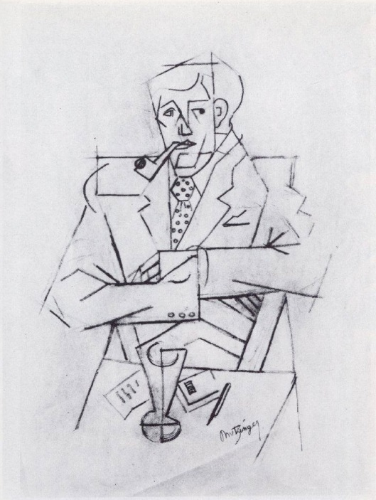

Jean Metzinger, ‘Étude pour le portrait de Guillaume Apollinaire’ (1911). Held at the Musée National d'Art Moderne, Centre Georges Pompidou, Paris.

https://upload.wikimedia.org/wikipedia/en/4/4a/Jean_Metzinger,_1911,_Etude_pour_le_portrait_de_Guillaume_Apollinaire,_Mine_graphite_sur_papier_verg%C3%A9_rose,_48_x_31.2_cm,_Mus%C3%A9e_national_d'Art_moderne,_Centre_Georges_Pompidou,_Paris.jpg

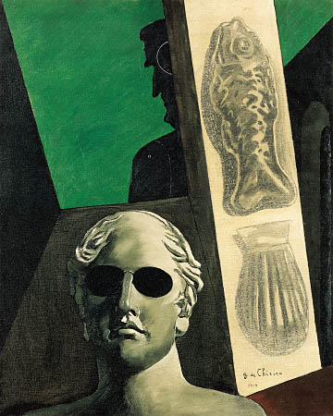

Giorgio de Chirico, ‘Portrait prémonotoire de Guillaume Apollinaire’ (1914)

<https://www.centrepompidou.fr/id/cazbyy/rG9zK4/fr>

**List of works by Apollinaire:**

*English translations are listed where available

**Collections:**

*Selected Writings of Guillaume Apollinaire*, ed. and trans. Roger Shattuck, New York: New Directions, 1971

**Poetry:**

*Oeuvres Poétiques* *Complètes* (Paris: Gallimard, 1956) [collected poetry, in French]

*Alcools* (Paris: Mercure de France, 1913) [a later Gallimard edition is available at archive.org: <https://archive.org/details/alcoolspomes1800apol>]

*Alcools. Poems by Guillaume Apollinaire*, trans. by Donald Revell (Middletown, CT: Wesleyan University Press, 1995)

*Calligrammes: Poèmes de la Paix et de la Guerre 1913-1916* (Paris: Mercure de France, 1918) [images of the first edition are available at archive.org: <https://archive.org/details/calligrammespo00apol>]

*Calligrammes: Poems of Peace and War 1913-1916*, trans. by Anne Hyde Greet (Berkeley: University of California Press, 1980)

*Le Bestiaire or Cortège d’Orphée* (Paris: Deplanche, 1911)

*Vitam Impendere Amori* (Paris: Mercure de France, 1917) [also contains *Alcools*, *Le Bestiaire*]

*Il y a* (Paris: Messein, 1925)

*Le Guetteur Mélancolique* (Paris: Gallimard, 1952)

*Ombre de mon Amour* (Geneva: Pierre Cailler, 1947) [later reprinted as *Poèmes à Lou*]

**Prose:**

*L’Enchanteur Pourrissant* (Paris: Henry Kahnweiler, 1909)

*Les Onze Milles Vierges* (1906-7)

*L’Hérésiarque et Cie* (Paris: P.V. Stock, 1910) [text available at http://www.gutenberg.org/files/22356/22356-h/22356-h.htm)]

*Les Exploits d’un Jeune Don Juan* (1911)

*Le Poète Assassiné* (Paris: Bibliothèque des Curieux, 1916)

*La Femme Assise* (Paris: Éditions de la Nouvelle Revue Française, 1920)

*L’Histoire Romanesque* (Paris: Bibliothèque des Curieux 1914) [3 volumes, the 3rd was unpublished]

**Plays:**

*Les Mamelles de Tirésias* [1917] (Paris: Éditions SIC, 1918).

*Couleur du Temps* (Paris: Éditions du Bélier, 1918)

*Casanova* (Paris: Gallimard, 1952)

With André Salmon: *Jean-Jacques, La Temperature, Le Marchand d’anchois*

**Screenplay:**

*La Bréhatine* (1917) [with André Billy]

**Criticism:**

*Guillaume Apollinaire: Chroniques d’Art 1902-18* (1960) [collected edition of art criticism, translated by Roger Shattuck into English as *Apollinaire on Art: Essays and Reviews 1902-18* (MFA Publications, 2001).]

*Les Peintres Cubistes:* *Meditations Esthétiques* (Paris: Figuière, 1913) [translated by Peter F. Read into English, with commentary, as *The Cubist Painters* (Berkeley: University of California Press, 2004).]

*L’Antitradition Futuriste* (1913)

*L’Esprit Nouveau et les Poètes* (26 November 1917)

**Further Reading:**

Bohn, Willard. *Apollinaire and the International Avant-Garde* (Albany: State University of New York Press, 1997).

---. *Apollinaire, Visual Poetry, and Art Criticism* (Lewisburg: Bucknell University Press, 1993).

---. *Modern Visual Poetry* (Newark: University of Delaware Press, 2001).

Campa, Laurence. *Gauillaume Apollinaire* (Paris: Gallimard, 2013). [a critical biography in French]

Hunter, David. *Apollinaire and the Great War 1914-1918* (London: Peter Owen, 2015).

Lehman, David ‘Apollinaire’s Zone,’ *Virginia Quarterly Review: A National Journal of Literary & Discussion* (Spring 2013). Available at: http://www.vqronline.org/translations/apollinaires-zone

Read, Peter. *Picasso and Apollinaire: The Persistence of Memory* (Berkeley: University of California Press, 2008).

Read, Peter F., and Guillaume Apollinaire. *The Cubist Painters*. Trans. with commentary by Peter Read (Berkeley: University of California Press, 2004).

Revie, Ian ‘Apollinaire and Cubist Innovation: Resetting the Frontiers, Changing the Paradigm,’ *European Avant-Garde: New Perspectives*, ed. Dietrich Scheunemann (Amsterdam: Rodopi, 2000), 83-95.

Steegmuller, Francis. *Apollinaire: Poet Among the Painters* (London: Rupert Hart-Davis, 1963).